BCPR342 SERVER SIDE PROGRAMMING

**TOURS SYSTEM TODOS**

**Question 1**

The build1.php script builds a database structure that is used for the exercise. Examine the contents of this script and draw the Entity Relationship Diagram (ERD) that corresponds to the database that this builds. The ERD should show the following clearly:

* Entity names
* Field/attribute names and their data types
* Relationships and their multiplicity

**Question 2**

For this question run the mainA.php script.

A Build the database and load sample data. This will create the Tour, Customer,

and Booking tables. It also loads sample data into all tables except the Booking table.

B When you click on the “Add new Bookings for a Customer” link on the mainA

page the following will be displayed.

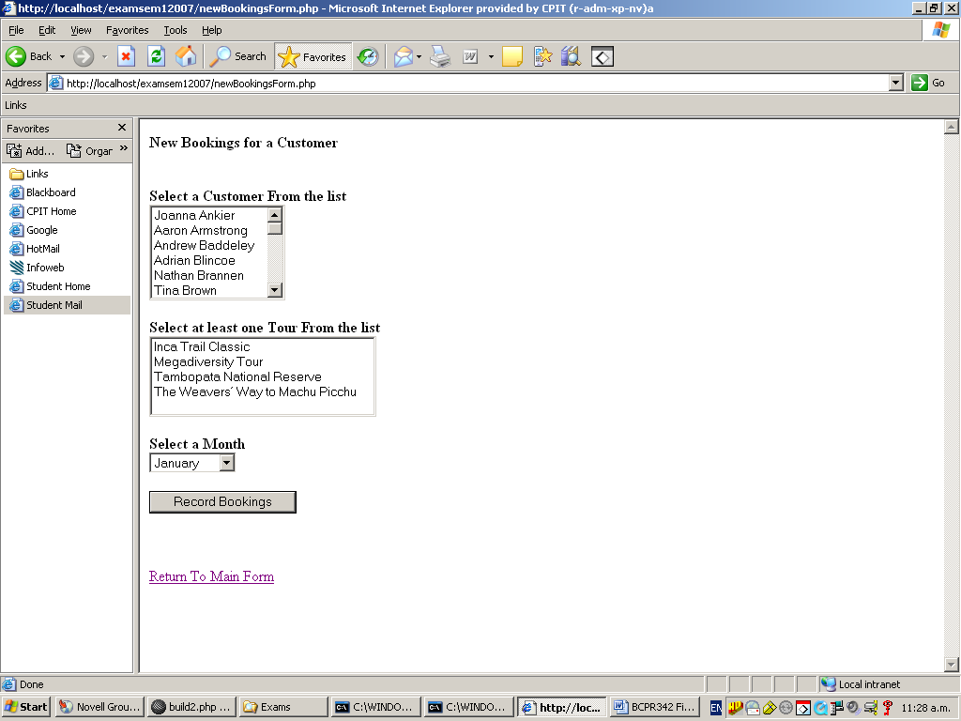

If the user was to (for example), select “Tina Brown” as the customer, select “Inca Trail Classic” and “The Weavers Way to Machu Picchu” as the Tours and select “June” as the month, the addBookings.php script should be loaded, and the following should be displayed: (Note that it does not do this yet):

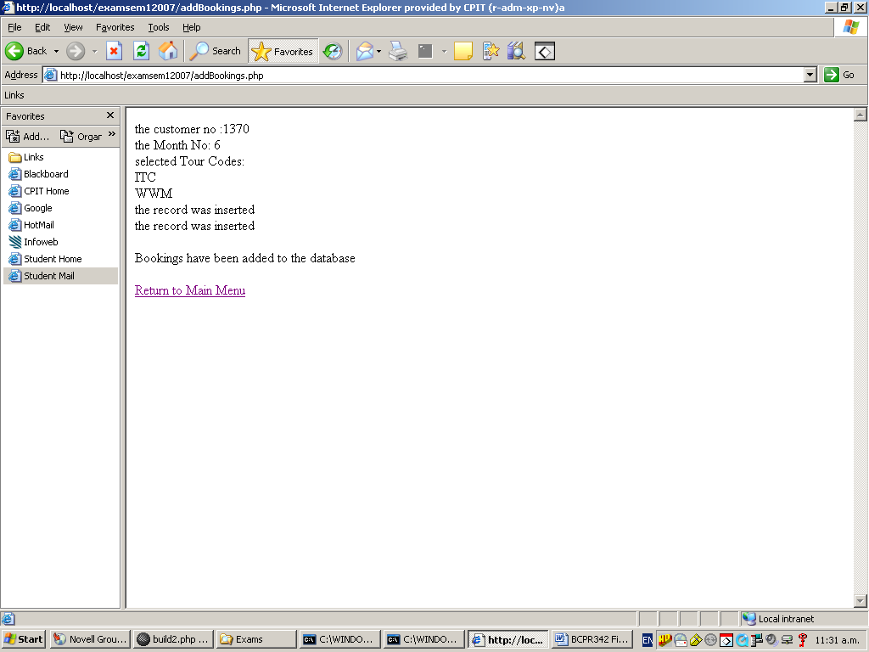

Four (4) pieces of code need to be written to make this work. The first three (3) pieces of code are to be written in the newBookingsForm.php script with the fourth piece of code to be written in the addBookings.php script.

* 1. In the place shown in newBookingsForm.php, write code to store the data that has been selected or entered on the form in the variables named $theCustomerNo, $theTourCodes and $theMonthNo.
  2. In the place shown in newBookingsForm.php, write the code for the isValidForm function to check that a customer, at least one tour and a month have been selected. A meaningful error message should be displayed for each of these that has not been done.
  3. In the place shown in newBookingsForm.php, write code to register the session variables and to redirect output to addBookings.php.
  4. In the place shown in addBookings.php, write code to load the session

variables and then display the customerNo, the monthNo and the

selected tour codes.

* 1. In the place shown in addBookings.php, write code to insert the details of the new entries into the Booking table.

**Question 3**

For this question use the mainB.phpscript.

A **Build the database and load sample data.**

This will create the Tour, Customer, and Booking tables. It also loads sample data into all the tables including the Booking table which now also contains the deposit amounts.

B When you click on “Display Selected Bookings” the following will be displayed.

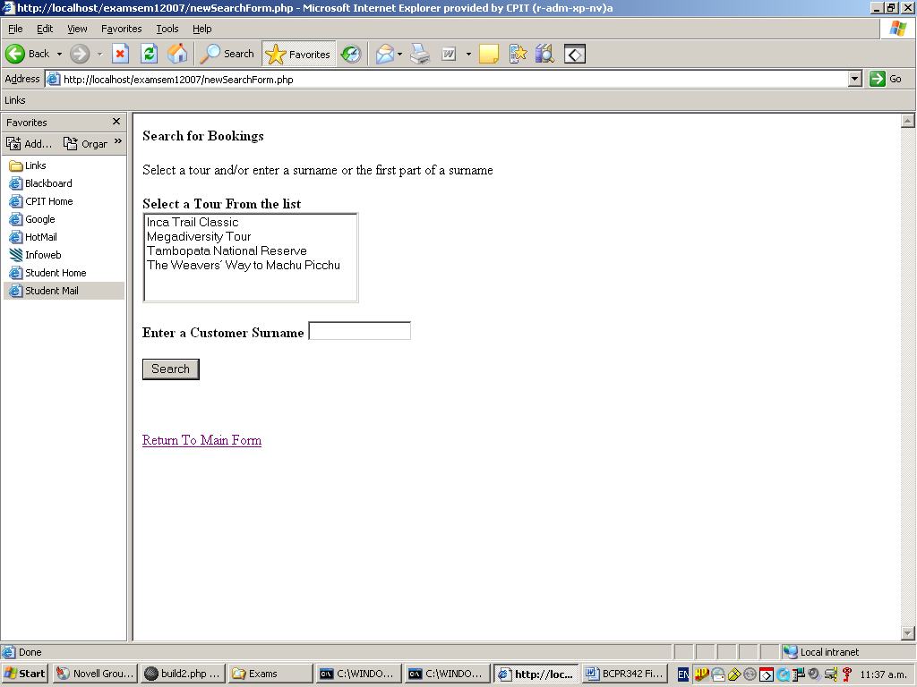

If a tour is selected and/or a surname or partial surname is entered the selections are stored in variables, the search.php script is loaded and the relevant results are displayed. Eg. if “m” is entered as the surname the following should be displayed (note that it does not do this yet).

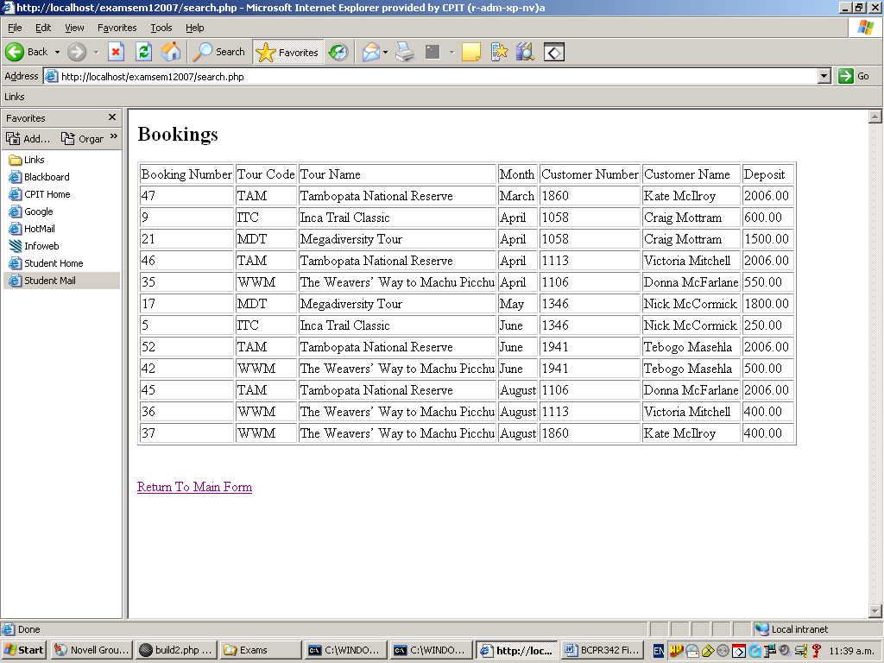

If just the “Inca Trail Classic” tour is selected the following should be displayed:

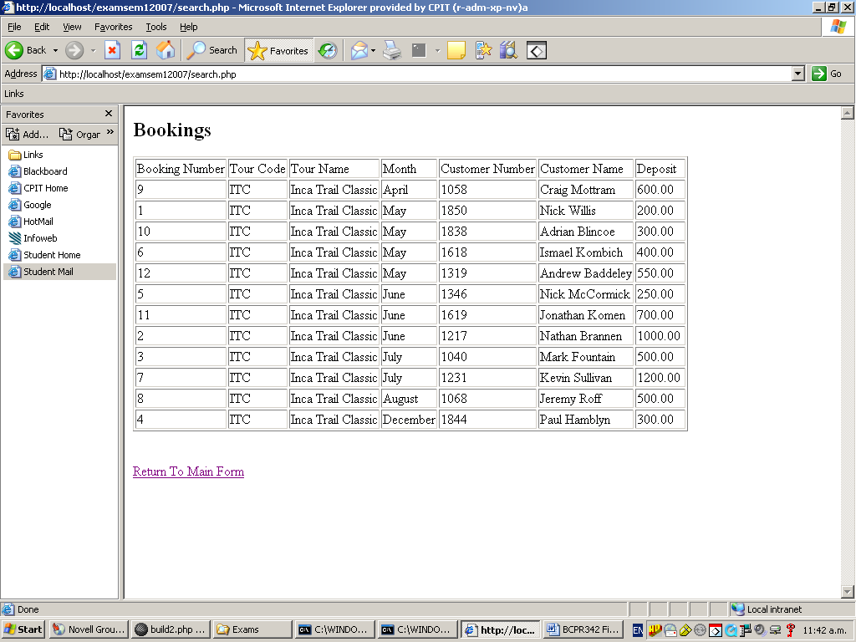

If the “Megadiversity” tour is selected AND “k” is entered for the surname then the following should be displayed:

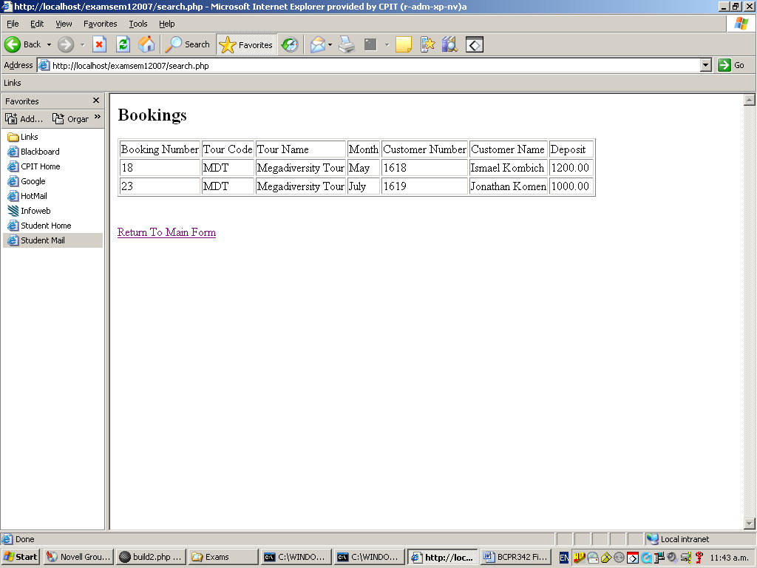

1. Write a getBookings2 function in the MyFunctions script.

1. Use this function to complete the coding of search.php.

**Question 4**

For this question run the mainB.php script.

When you click on “Search Tours” the following will be displayed.

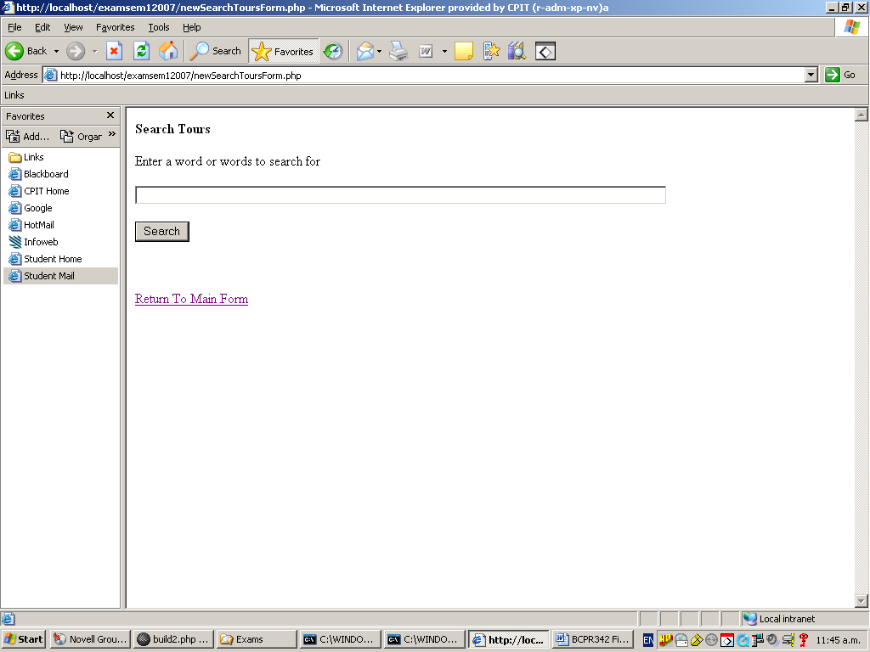

Ifthe words “inca” and “amazon” are entered then the search will return the following: (note that it does not do this yet)

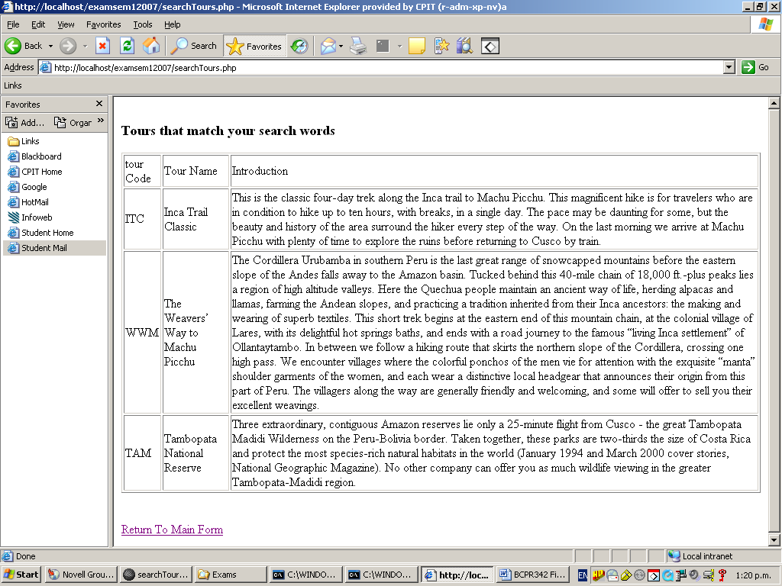

i.e. tours that contain “inca” OR “amazon” in the tourName or introduction fields.

1. Modify build2.php so that a fulltext search on tourName and introduction is possible.

1. Write a function or method that will return the matching tours.

1. Complete the coding of searchTours.php